  Adolfo Andrés Hincapié García |  | 
Nationality: | Colombia
WhatsApp: | +57 350 743 9527
Date of Birth: | 4 May 1986
Language(s): | Spanish (mother tongue); English; Portuguese
Email address | aahincap@unal.edu.co; bandreshin@gmail.com

Profile

Forestry Engineer and Anthropologist with a Master’s in Geospatial Environmental Modeling, combining technical, social, and spatial skills to support land-use transitions and climate resilience. Over 6 years of international experience in carbon certification for voluntary and 2 years in GHG Protocol with expertise in methodologies such as VCS, CCB, and Gold Standard across AFOLU project types (REDD+, ARR, ALM, IFM). Fluent in GIS, stakeholder engagement, and human rights approaches, with a proven record leading Nature-Based Solutions and decarbonization initiatives in Latin America, Africa, and Southeast Asia.

Adaptable, multilingual (Spanish, English, Portuguese), and committed to designing high-integrity climate interventions that generate social, environmental, and financial co-benefits.
My journey in the carbon market began in 2017 at South Pole as a Geospatial Analyst, where I supported and later led the development of nature-based solutions (NbS) in Latin America. I coordinated AFOLU projects across multiple countries, contributing to feasibility assessments, GHG estimations, spatial analysis, and the design of Theory of Change (ToC) frameworks.

Currently, I offer technical and strategic advisory services to multiple organizations on a freelance basis, providing hourly support for carbon certification, project validation, and MRV alignment.

Website: https://aahincapie.github.io/about/

Education

Federal University of Minas Gerais  Belo Horizonte, Brazil  2017 | M.Sc.  Analysis and Modeling of Environmental Systems, Brazil, Belo Horizonte.  Scholarship: Coordenação de Aperfeiçoamento de Pessoal Alto Nivel (CAPES).
University of Antioquia  Medellín, Colombia  2013 | B.Sc.  Anthropology, Colombia, Medellín.
National University of Colombia  Medellín, Colombia  2012 | B.Eng  Forest Engineering, Colombia, Medellín.

Main skills and interest

The chart maps key areas for business growth contributions, ranging from usual carbon credit mechanisms to emerging opportunities like GHG Jurisdictional REDD+, GHG Protocol, Value Chain (Scope 3), and Article 6.

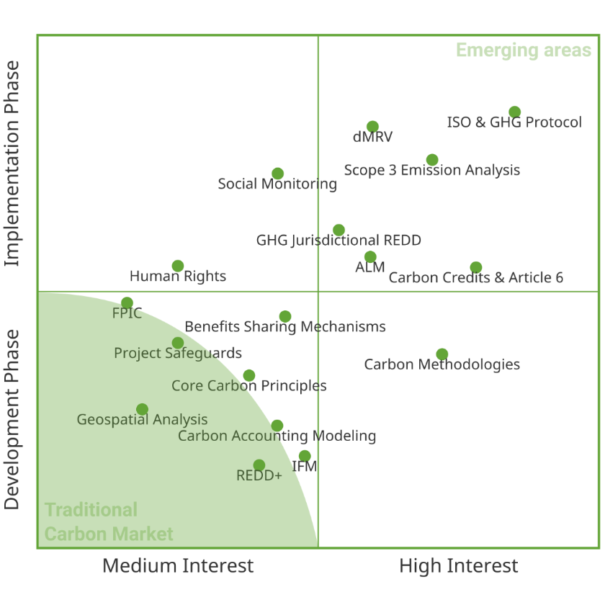
Work experience

Freelance Consultant, Multiple Employers – Remote (Oct 2024 – Present)
- Provide technical and strategic advice to carbon project developers to ensure compliance with leading carbon standards and methodologies (including VCS, GS, Social Carbon, and VCI).
- Support feasibilities, project documents, monitoring, and verification processes across REDD+, ARR, for organizations such as Verra, Forliance, Xilva, Enviroaccounts, Klymare, Carbon Credit Consulting, Treevaluation among others on project documentation review, compliance reviews, and emissions accounting.

Carbon Compliance Expert, Earthshot Lab, Remote (Oct 2023 – Oct 2024)
- Advise projects and clients to ensure compliance with carbon standards and regulations (including ART/TREES, VCS, GS, Social Carbon, or Scope 3). Contribute to Earthshot Lab's mission to protect natural ecosystems and combat climate change by supporting the technical and scientific team and providing inputs for Reducing Emissions from Deforestation and Forest Degradation (REDD), Improved Forest Management (IFM), and Afforestation Reforestation (ARR) initiatives into a machine learning technology to analyze carbon projects (LandOS platform).

Regional Lead NBS, Climate Projects, South Pole, Colombia (Jan 2023 – Oct 2023)
- Led the implementation and management of emission reduction projects, including drafting feasibility studies, project design documents (PDDs), monitoring reports (MRs), and providing technical and business development support. Led knowledge management and stayed up to date on the latest rule changes. Led community revalidation process of Chyulu Hills REDD+, supporting climate and JNR requirements for climate project, and support sourcing and other managers in the company, and providing technical reviews.

Senior Project Coordinator – AFOLU, South Pole, Colombia (Jan 2021 - Dec 2022)
- Led the implementation and management of emission reduction projects, including leading and drafting feasibility studies and project design documents (PDDs), validation, monitoring, reporting, and verification (MRV) support under different standards (T-VER, CDM, VERRA, GS4GG). Provided technical and business development support with the project sourcing team.

Project manager | Forestry & Land Use Projects, South Pole, Colombia (Jun 2019 – Dec 2020)
- Provided support for developing REDD and ARR projects related to GIS, forestry, and community issues. Supported the selection of projects, following up with stakeholders, and conducting due diligence on Brazilian projects.
- Developed operational inputs for local site visits and consultations with local stakeholders. Assisted with the development of project proposals.

GIS | Forestry & Land Use Projects, South Pole, Colombia (Jun 2017 – Jun 2019)
- Processed satellite and other remote sensing images to generate land cover maps for Peru (AIDER-Minagri). Provided technical support for the development of REDD and ARR projects. Developed a GIS and methodological construction of primary conditions for a jurisdictional approach based on carbon for Caquetá, Colombia. Developed a spatially explicit modeling and baseline evaluation for a jurisdictional approach on Isangi, Democratic Republic of Congo.

Environmental Analyst, WWF-OIA, Colombia (May 2016 - Dec 2016)
- Implemented participatory agreements, concepts, and strategies for the management of indigenous territories by developing spatial and GIS methodological designs with a participatory approach.
- Led inter-ethnic actions for defending indigenous territories and legal actions for the rights of Mother Earth against illegal mining in indigenous territories. Interacted and dialogued with governmental institutions and other stakeholders.

Consultancy, Universidad Nacional de Colombia, Colombia, Colombia (May 2016 - Jul 2016)
- Methodological designs for forest degradation in Colombia based on timber products. Interviews with timber stakeholders and focus groups of the forestry sector. Compilation of information on forest harvesting and timber products associated with forest degradation in Colombia. (Contract 2302831 of 2016 between FAO and the UN to ONUREDD)

Assistant professor, Universidade Federal de Minas Gerais, Brazil (Jul 2015 - Dic 2015)
- Tutoring the learning process to Environmental Engineer. Apply the assessments and others. Topics: History of cartography, Conceptual frameworks, Thematic Cartography and principles of remote sensing applied to monitoring the Earth.

Land Tenure and Land Use Advisor, Indigenous Organization of Antioquia, Colombia (Jul 2013 - Feb 2015)
- Incorporating spatial criteria of environmental regulation (risk, potential, and planning) into five indigenous livelihood plans of indigenous territories. Supporting activities in land tenure, land use, and projects of payments for environmental services and right to free, prior, and informed consent.

Forestry and Anthropologist (Consultancy), Renovatio Group Ltda, Colombia (Sep 2013 - May 2014)
- Developing the characterization of the area of influence in wind farm project, physical and biotic components. Environmental, Social and Corporate Governances (ESG) performance Asses. Geodatabase managing and others.
- Supporting social-environmental operations on wind farm project license
- Guiding environmental licenses and government permits regarding to free prior and informed consent

Anthropologist, Community Global Partership CGP.s.a.s, Colombia (Sep 2012 - Feb 2013)
- Developing a methodological approach to local stakeholders’ consultation for the REDD+ project Guainía; Mapping and characterization of agents of deforestation, direct causes and underlying, and perspectives of evolution in the indigenous land of the department of Guainía.

Countries of Work Experience

- Colombia
- Brazil
- Peru
- Guatemala
- Democratic Republic of Congo
- Congo
- Ghana
- Ivory Coast
- Kenya
- Indonesia
- Cambodia
- Philippines
- New Zealand

Personal references

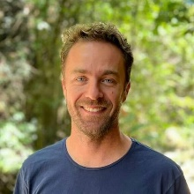 | Abel Marcarini: Abel is a carbon project lead for Brazil at Earthshot Labs. He has more than 10 years working on Nature Based Solutions for the voluntary carbon market and academic background in forestry. Before Earthshot Lab, Abel worked for Verra for two years and for South Pole for seven years.
Email: abel@earthshot.eco
Phone: +55 21 98390-3179

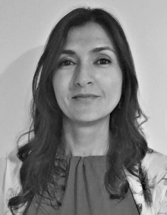 | Beatriz Zapata: Betty is a forest engineer with vast experience in carbon forest project initiatives. She has deep technical knowledge of methodologies, tools, and guidelines of the main standards used in the AFOLU sector, such as VCS, CCBS and Gold Standard. Beatriz has been working for South Pole for more than seven years.
Email: b.zapata@southpole.com
Phone: +57 301 6315941

 | Milena Agudelo: Milena is a manager for Nature Climate Solutions at Verra, responsible for reviewing registration and verification requests ensuring quality and integrity of ALM and WRC projects. She helps develop updates to existing rules and procedures and provides technical input for the development of new methodologies. Milena holds a bachelor’s degree in Forest Engineering and a MSc in Forestry and Environmental Conservation. Previously, she supported Climate Friendly and South Pole for six years.
Email: cagudelo@verra.com
Phone: +57 310 5470215

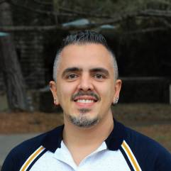 | David Montoya González: David hold eight years of extensive experience in Remote Sensing and GIS. He leads the Remote Sensing and GIS team in TerraGlobal, using innovative software and tools that meet carbon market and impact standards and support community-based geospatial community monitoring. David worked for The National Department of Statistics (DANE) and South Pole for two years.
Email: gonzalez@terraglobalcapital.com
Phone: +57 300 4529610

Other mentors

Britaldo Soares-Filho | Google Scholar
Sonia Maria Carvalho | Google Scholar
Dolors Almenteras | Google Scholar

Key experience by regions

Region/Country | Year(s) | Project & Client | Roles
Africa
Ghana/Ivory Coast | 2024 | Scope 3 Assessment (Lindt & Sprüngli) | Greenhouse Gas Protocol Corporate Value Chain (Scope 3) Standard and allocation methodologies for cocoa supply chains
DRC | 2020 | Isangi REDD+ (Safboi) | Nesting project-level REDD+ activities within jurisdictional program; Development of Verra Jurisdictional REDD+ framework (Version 1)
Kenya | 2023 | Chyulu Hills REDD+ (Maasai Wilderness) | Baseline Reassessment for CCB and VCS; Reanalysis of historical deforestation; Review of business-as-usual projections and indicators
Republic of Congo | 2023 | Ngabe (Aither) | Assessing and mitigating potential leakage and shifing potential; Aligning with Gold Standard's safeguard requirements
Kenya | 2018 | Lake Naivasha (JB Travel AB) | Collaboration preparing the Project Design Document (PDD)
Southeast Asia
Indonesia | 2024 | Flores REDD+/ARR (BirdLife International) | Assessing financial, institutional, and technical feasibility, Analyzing project location and elegibility in field.
Cambodia | 2023 | Lomphat Wildlife Sanctuary (BirdLife International) | Preparing support documentation for VCS and CCB validation
Latin America
Brazil | 2019 | Serra do Amolar REDD+ (Instituto Homem Pantaneiro) | Initial project validation against VCS and CCB standards, Support monitoring, reporting, and verification, and support issuance of VCUs
Brazil/Peru | 2018 | ISA Jaguar Fund (Interconexión Eléctrica S.A.) | Analyzing project location and eligibility; Assessing financial, institutional, and technical feasibility for AFOLU projects
Colombia | 2020 | Morrosquillo Blue Carbon (INVEMAR/Conservation International) | Preparing support documentation for VCS and CCB validation
Colombia | 2019 | Sierra Nevada REDD+/ARR (TNC) | Analyzing project location and eligibility; Assessing financial, institutional, and technical feasibility for AFOLU activities (ARR/REDD)
Colombia | 2017 | Deforestation Study (GIZ) | Identifying the direct and underlying drivers of deforestation; Mapping the key actors and stakeholders involved

